TitlE of the article
Firstname LASTNAME*, Firstname LASTNAME², Firstname LASTNAME³
¹Affiliation
²Affiliation
³Affiliation
Received xx xxxx 2026; revised xx xxxx 2026; accepted xx xxxx 2026
Abstract. A single paragraph of approximately 200 words providing a clear and relevant overview of the work. It should briefly introduce the research question and purpose, outline the key methods used, highlight the main results and state the principal conclusions or interpretations. It must accurately reflect the content of the paper and only include results supported in the main text.
Keywords: keyword 1; keyword 2; keyword 3 (List three to eight keywords specific to the article)
JEL Classification: text.,
1. Introduction
Text text text text text text text text text text text text text text text text text text text text text text text text text text text text text text text text text.
Text text text text text text text text text text text text text text text text text text text text text text text text text text text text text text text text text
2. Heading
Text text text text text text text text text text text text text text text text text text text text text text text text text text text text text text text text text .
Text text text text text text text text text text text text text text text text text text text text text text text text text text text text text text text text text
Table 1. Title of the Table (source: )
 | Text | text
Text
Length, cm | 17.30 ± 0.837 | 21.40 ± 4.164
Weight, g | 95.43 ± 14.581 | 205.18 ± 116.835
Biomarkers
HCT, L-L⁻¹ | 0.25 ± 0.038 | 0.26 ± 0.040
CF | 1.84 ± 0.151 | 1.92 ± 0.168

Text text text text text text text text text text text text text text text text text text text

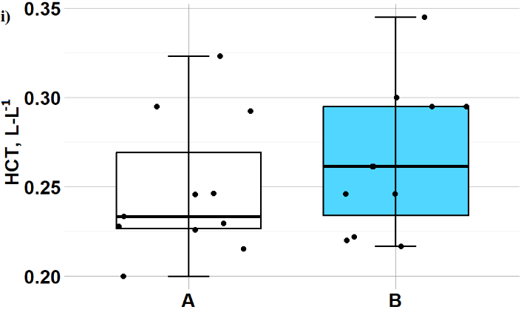
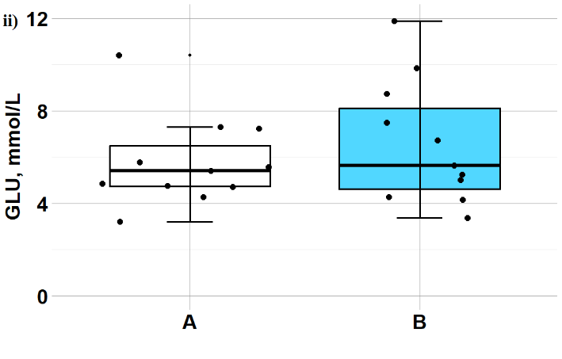
Figure 1. Title of the Figure
Text text text text text text text text text text text text text text text text text text text text text text text text text text text text text text text text text
(1)
text text text.
.....
3. Conclusions
Text text text text text text text text text text text text text text text text text text text text text text text text text text text text text text text text text .
Text text text text text text text text text text text text text text text text text text text text text text text text text text text text text text text text text
References
(All sources must be cited and referenced using the APA citation style)
Afiyah, Fira, M. D., Santanumurti, M. B., Jamal, M. T., Muttaqin, A., Subekti, S., & Sari, P. D. W. (2023). Blood glucose profile as a rapid method for observing Koi carp (Cyprinus carpio) health status – Case study of ectoparasites in Blitar, Indonesia. Revista Brasileira de Parasitologia Veterinária, 32(2), Article e014622. https://doi.org/10.1590/s1984-29612023019
Balasch, J. C., & Tort, L. (2019). Netting the stress responses in fish. Frontiers in Endocrinology, 10. https://doi.org/10.3389/fendo.2019.00062
Baltic Marine Environment Protection Commission. (2013). HELCOM Copenhagen Ministerial Declaration. https://helcom.fi/wp-content/uploads/2019/08/2013-Copenhagen-Ministerial-Declaration-w-cover-1.pdf
European Commission. (2023). Water framework directive. Environment. https://environment.ec.europa.eu/topics/water/water-framework-directive_en

